Real-Time Automated Cyber Threat Classification and Emerging Threat Detection Framework

ABSTRACT
Automating cyber threat intelligence (CTI) collection and analysis in real time is critical for the timely detection and mitigation of cyber threats. Cybersecurity researchers have recently recommended CTI as a proactive and robust method for automated cyber threat prediction. This automated solution collects and analyses real-time data from social media, cybersecurity forums, and hacker forums where cybersecurity analysts and hackers discuss cybersecurity-related topics to discover potential threats. In this article, we propose a comprehensive framework that automates both cyber threat classification and emerging threat detection using real-time data from surface, deep, and dark web sources. We collected real-time data from hackers and security forums to construct binary and multiclass cyber threat classifications. We employed a labelled leaked dataset to be considered as ground truth for classification. Machine and deep learning techniques were used to perform the classification. Latent Dirichlet allocation (LDA) and nonnegative matrix factorization (NMF) were used to analyse topic distribution over time and identify emerging threats. This approach allows for the identification of zero-day attacks and other emerging threats by monitoring shifts in topics. Using a support vector machine with the bag-of-words (binary term weight) model achieved the highest accuracies of 93.67 and 96.35 for binary and multiclass classifications, respectively. Moreover, LDA and NMF were used to extract the top topics from various numbers of topics. The LDA model is well suited for identifying emerging trends and useful for real-time threat monitoring in cybersecurity.

KEYWORDS
Cyber Threat Detection, Real-Time Data Collection, Machine Learning, Deep Learning, Natural Language Processing (NLP), Text Mining, Cyber Threat Intelligence (CTI), Topic Modeling, LDA, NMF, SVM, Random Forest, XGBoost, CNN, LSTM, Binary Classification, Multiclass Classification, Bag of Words (BoW), Threat Analysis, Zero-Day Attack Detection.

EXISTING SYSTEM
The existing cyber threat detection system relies on collecting real-time textual data from hacker forums, social media platforms, and cybersecurity discussion websites. After collecting the data, Natural Language Processing techniques are used to clean and preprocess the text. The processed data is converted into numerical vectors using the Bag of Words (BoW) encoding method. Various Machine Learning and Deep Learning algorithms such as Support Vector Machine (SVM), Random Forest, XGBoost, Naïve Bayes, CNN, and LSTM are trained to classify cyber threats into binary and multiclass categories. Topic modeling algorithms including Latent Dirichlet Allocation and Non-negative Matrix Factorization (NMF) are used to identify emerging cyber threat topics and monitor changing attack trends in real time.

DISADVANTAGES:
- Performance depends heavily on the quality of collected text data.
- Requires continuous data collection from multiple online sources.
- Deep learning models require high computational resources.
- Accuracy decreases when data contains noisy or misleading information.
- Topic modeling may not always detect newly evolving attack patterns accurately.

PROPOSED SYSTEM
The proposed system provides an automated framework for real-time cyber threat classification and emerging threat detection using Machine Learning and Deep Learning techniques. It continuously gathers cybersecurity-related text from public forums, hacker communities, and social platforms. After preprocessing with NLP techniques, the data is transformed using the Bag of Words encoding method for efficient feature representation. Multiple classification algorithms including SVM, Random Forest, XGBoost, CNN, Naïve Bayes, and LSTM are trained and evaluated for binary and multiclass threat prediction. LDA and NMF topic modeling methods analyse discussion trends to identify emerging cyber threats and possible zero-day attacks. The system enables accurate threat classification, continuous monitoring, and timely identification of new cyber-attack patterns without relying on manual analysis.
ADVANTAGES:
- Detects both binary and multiclass cyber threats.
- Uses real-time data for improved threat monitoring.
- Automatically identifies emerging cyber-attack trends.
- Reduces manual effort through intelligent automation.
- Supports early detection of zero-day attacks.

MODULE DESCRIPTION:
1. Data Collection Module
Collects cybersecurity-related textual data from hacker forums, social media platforms, security blogs, and public threat intelligence sources in real time.
2. Data Preprocessing Module
Cleans and preprocesses collected text using NLP techniques such as tokenization, stop-word removal, punctuation removal, and stemming to improve data quality.
3. Feature Extraction Module
Converts cleaned text into numerical feature vectors using the Bag of Words (BoW) technique for machine learning model training.
4. Threat Classification Module
Trains and evaluates multiple Machine Learning and Deep Learning algorithms such as SVM, Random Forest, XGBoost, Naïve Bayes, CNN, and LSTM to classify threats into binary and multiclass categories.
5. Emerging Threat Detection Module
Applies LDA and NMF topic modeling algorithms to analyse discussion trends, identify emerging cyber threats, and detect possible zero-day attacks in real time.
6. Result Analysis Module
Displays classification results, performance metrics (Accuracy, Precision, Recall, F1-Score), and visualizes detected threat categories and trending cyber-attack topics.

SYSTEM ARCHITECTURE

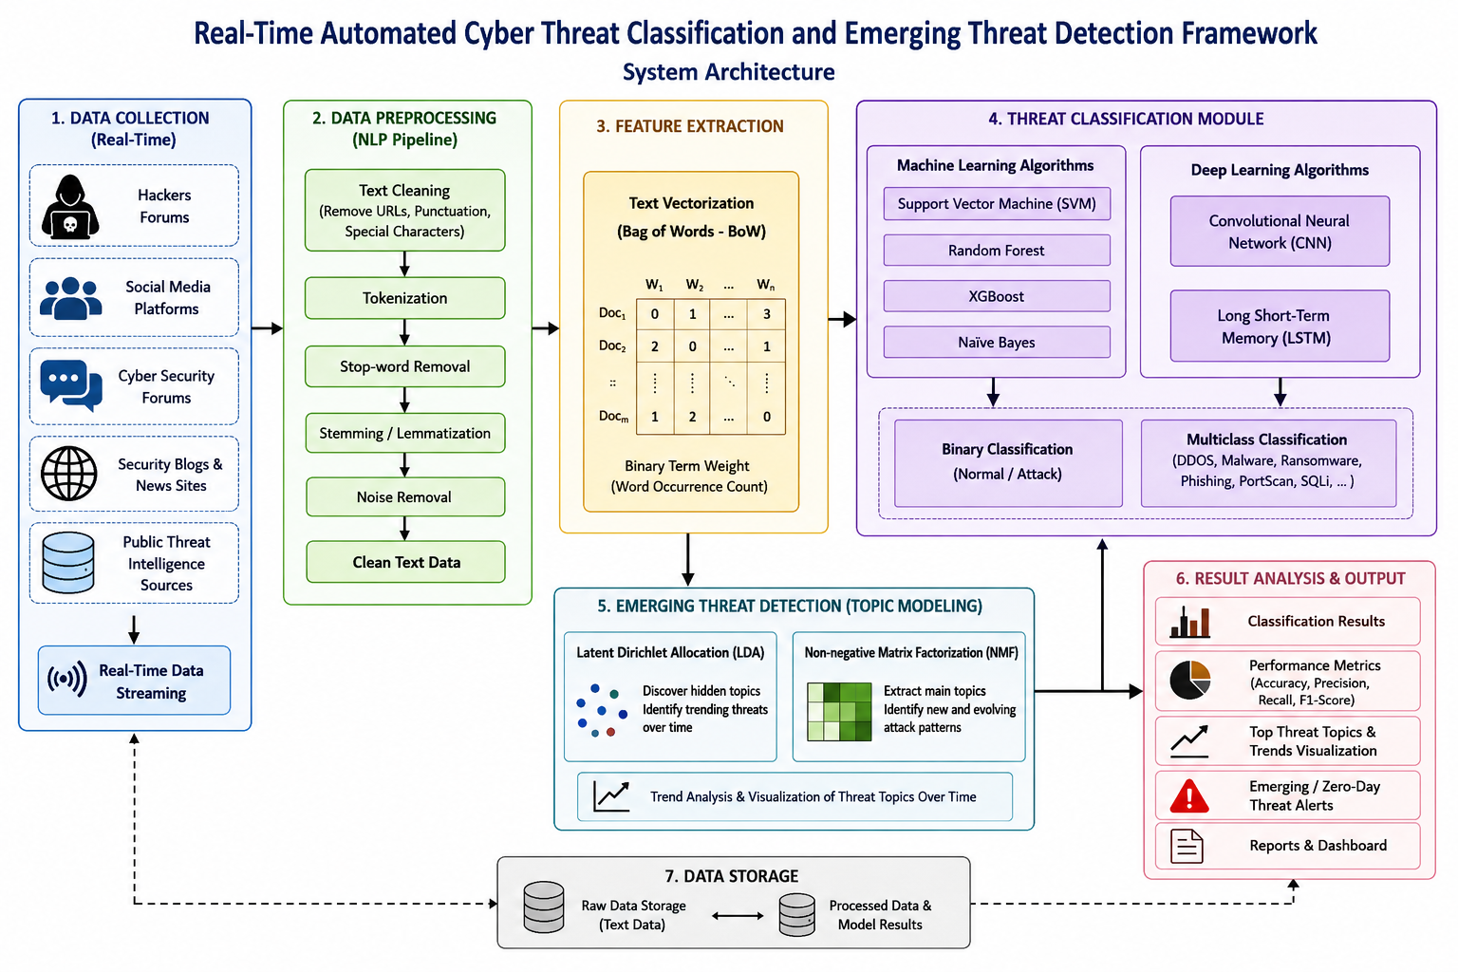

HARDWARE & SOFTWARE REQUIREMENTS:
HARDWARE REQUIRMENTS:
- Processor : intel i3(min)
- Hard Disk : 500 GB.
- Ram : 4 GB (min).
SOFTWARE REQUIRMENTS:
- Operating system : Windows 10 (min)
- Coding Language : python 3.7.0

